Guided Capstone Project Report

Background & Objective
Big Mountain Resort (Whitefish, Montana) recently installed a new chairlift, increasing seasonal operating costs by $1,540,000. To evaluate whether current pricing adequately covers this expense — and to identify the resort's optimal price point — a Random Forest regression model was built using data from 330 U.S. ski resorts. The model predicts a fair market Adult Weekend ticket price based on each resort's physical attributes.

Key Finding: Pricing Opportunity with Important Caveats
The model estimates Big Mountain's fair market ticket price at $97.96 — $16.96 above the current $81.00. However, nationally Big Mountain's price sits near the most common price point among U.S. resorts (Figure 1). More importantly, within Montana, Big Mountain already commands the highest ticket price among all state competitors (Figure 2). This suggests the $97.96 estimate reflects comparison against destination resorts in markets like Colorado and Utah — a different competitive set than Big Mountain's primary customer base.

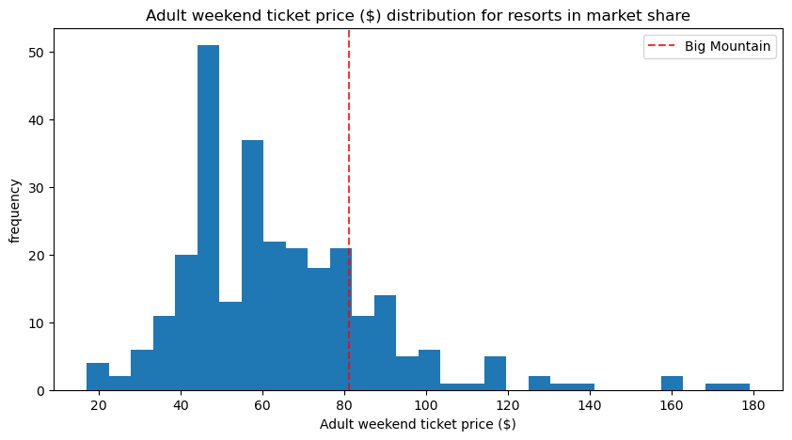  Figure 1. Big Mountain ticket price vs. all U.S. resorts. | 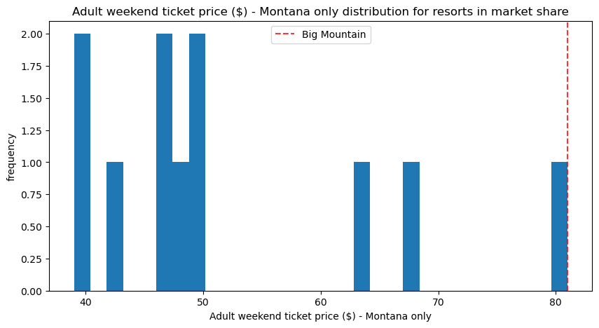  Figure 2. Big Mountain ticket price vs. Montana resorts — already the highest in state.

Scenario Analysis
Four operational scenarios were evaluated for their predicted impact on ticket price and seasonal revenue:

Scenario | Action | Price Change | Revenue Impact
1 — Baseline | Current pricing, no change | — | $0
2 — Chair Lift | Add run (150 ft lower) + new chair lift | +$2.22 | +$3.9M/yr
3 — Run Closures | Close 4–5 least-used runs | < −$1.50 | Cost savings
4 — Snow/Run Length | Minor snow-making / run extension | $0.00 | Negligible

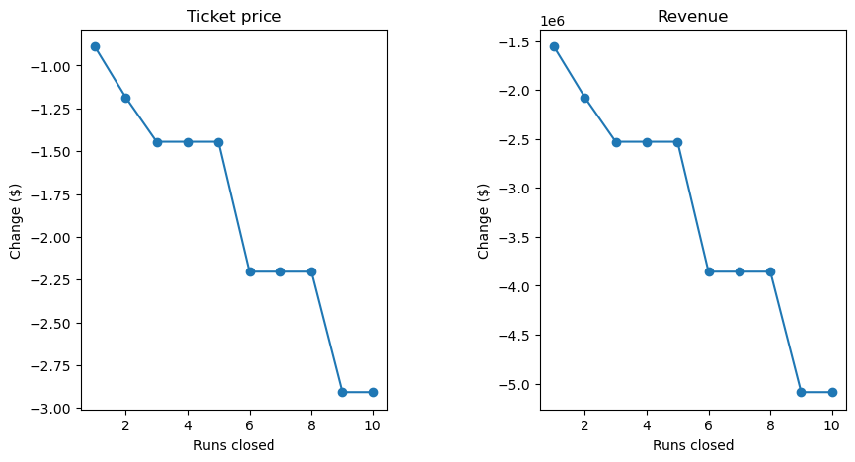
Figure 3. Predicted ticket price change (left) and revenue impact (right) for each run closure count. Revenue holds through 4–5 closures, then drops sharply.

Recommendations
- The model suggests the market supports a higher ticket price, but given the model's ±$9–10 error margin, Big Mountain's already leading position within Montana, and unaccounted customer expenses (lodging, food, rentals), any price increase should be approached cautiously and validated against competitor pricing and customer research before implementation.
- Proceed with the new chairlift investment. Scenario 2 supports a $2.22 price increase worth ~$3.9M in seasonal revenue — well above the $1.54M operating cost increase. The resort's top-tier vertical drop and run count make the expanded infrastructure credible to the market.
- Close 4–5 least-used runs for cost savings. The model shows minimal revenue impact at this level. Avoid closing 6 or more runs — the model predicts a sharp price decline beyond that threshold.
- Do not prioritize minor snow-making additions or small run-length extensions. Scenarios 3 and 4 produced zero modeled price movement and should be deprioritized.

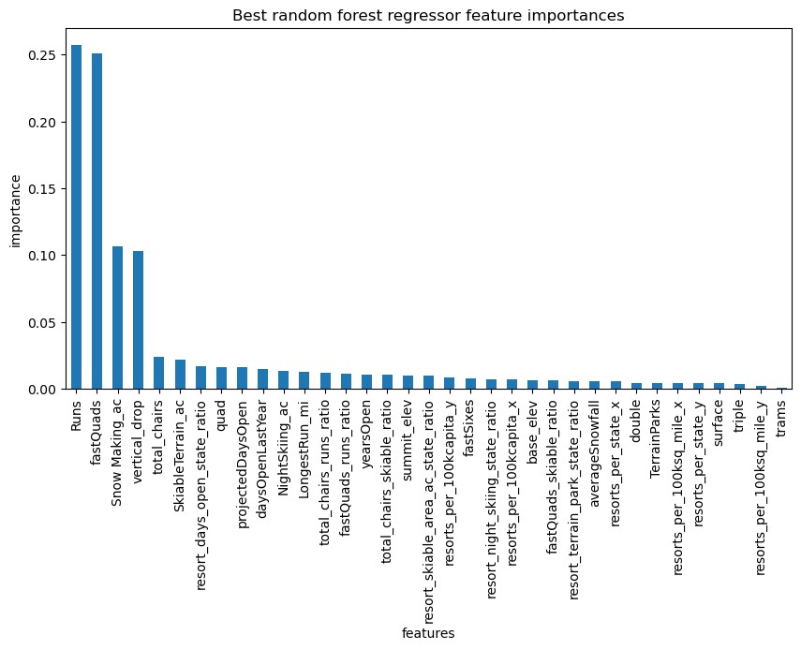
Figure 4. Random Forest feature importances — vertical drop, snow-making area, total chairs, fast quads, and total runs are the top five pricing drivers.

Model note: Random Forest regression (MAE ~$9.40) was selected over Linear Regression (MAE ~$11) for its superior generalization. Top pricing drivers — vertical drop, snow-making area, fast quads, and total runs — all align with Big Mountain's strongest competitive attributes.

